[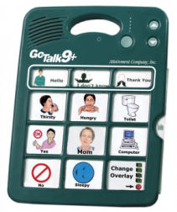](http://store.mayer-johnson.com/media/catalog/product/cache/1/image/5e06319eda06f020e43594a9c230972d/X/0/X0AT100.png)Augmentative Alternative Communication (AAC) Teaching Guide

Student __________________ Date_________ School ____________

Person (s) completing? __________________________________________________________

System being used ____________________________________

* Are the communication partners skilled at using the particular system before expecting the child to use it?
* Has the child had repeated exposure to and modeling of the system before being expected to respond? (System must be taught/child must be “immersed” in the language of AAC)
* Are communication opportunities/activities motivating for ***the child?***
* Would the child be more interested in doing the chosen activity than engaging in a problem behavior?
* Is the focus of the system interaction instead of “testing”? (example: “Uh oh…the paint spilled!” Vs. “Point to paint”)
* Does the system represent a variety of communicative functions? (i.e. commenting, gaining attention, asking questions, sharing information, joking/teasing)
* Is the vocabulary in the system specific to a particular activity so that necessary words are available? (ie; art, reading a book, computers)
* Does the system support learning new vocabulary to develop more complex language?
* Is the vocabulary organized for conversations to occur? (vs. requests only)
* Is the system used in an “errorless” way where any attempt by the child is acknowledged and scaffolded upon?
* Is the child allowed to explore and practice with the system?
* Is the system available at all times to the student? (vs. only snack)
* Has the child been given time to learn the system? (could take months or years)

Action Plan: What steps should staff take to support the student in learning AAC?

________________________________________________________________________________________________________________________________________________________________________________________________________________________________________________________________________________________________________________________________________________________________________